June 11, 2016 PrintAhead 2.0

The next version of PrintAhead is going to further simplify operation and also enhance success rate.

Main points:

1. Head shape will be set in the Set-Up dialog and will accommodate various head shapes.
2. The texture and shape operation will be joined – no need to set twice the same points.
3. Automatic color assignment to neck
4. Various fixes

**New Set-up process: ($250)**

Combine first two dialogs (Select and Set-up) into one.

Additional shape circles. In addition to present top-of-head and chin circles we will add six more as shown. These will shape the head for the different head types.

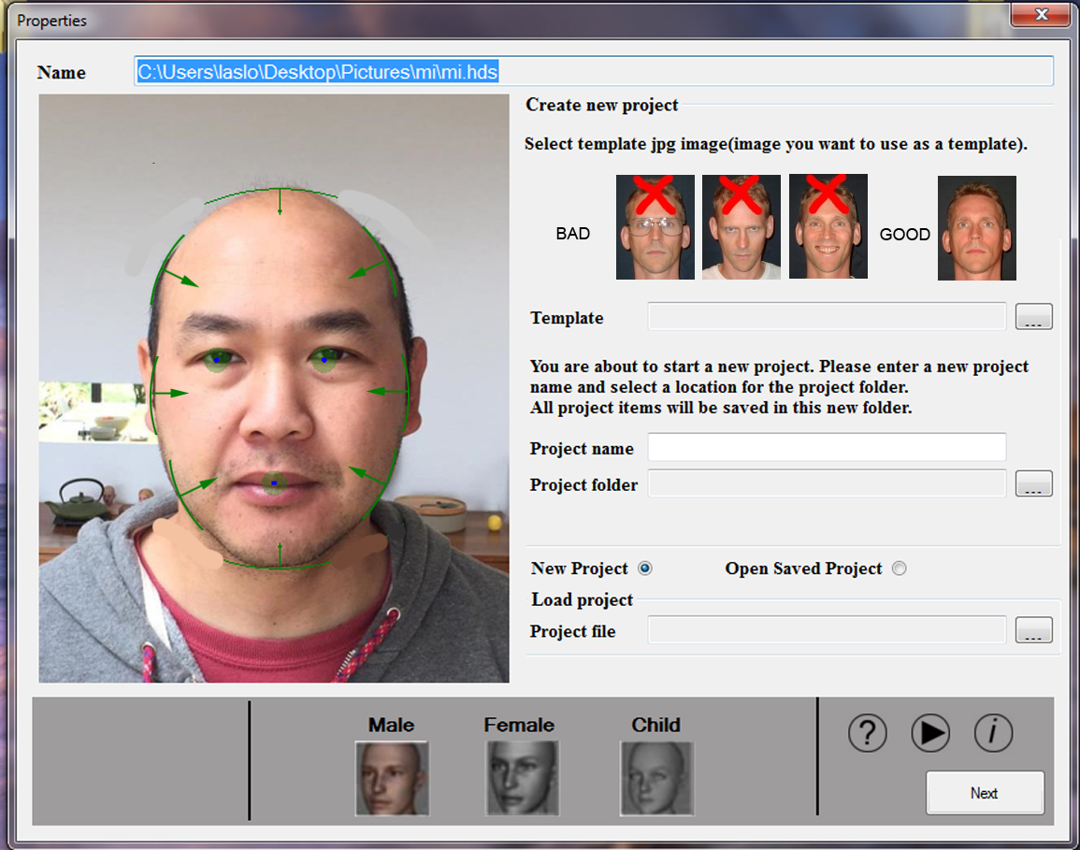

Current condition:

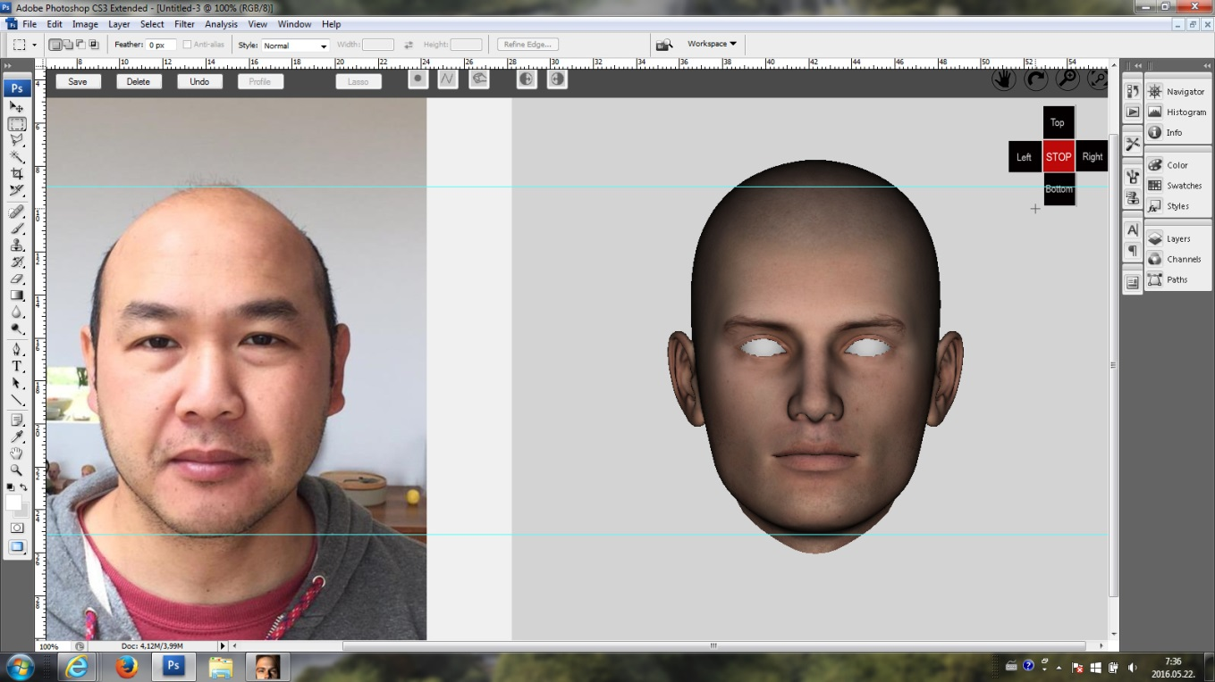

Desired condition. The net result is that once the user proceeds to the work area, head shape will be set and proportions correct.

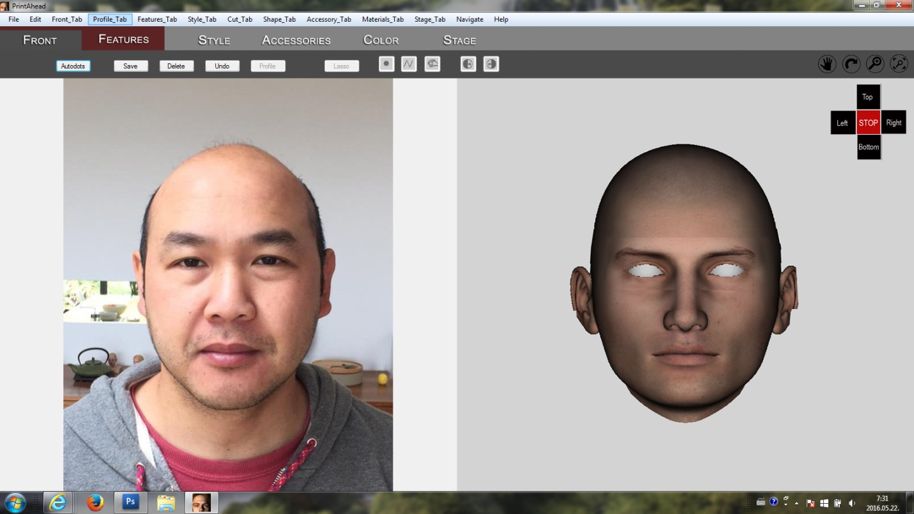

Important points: This arrangment need to preserve these important proportions.

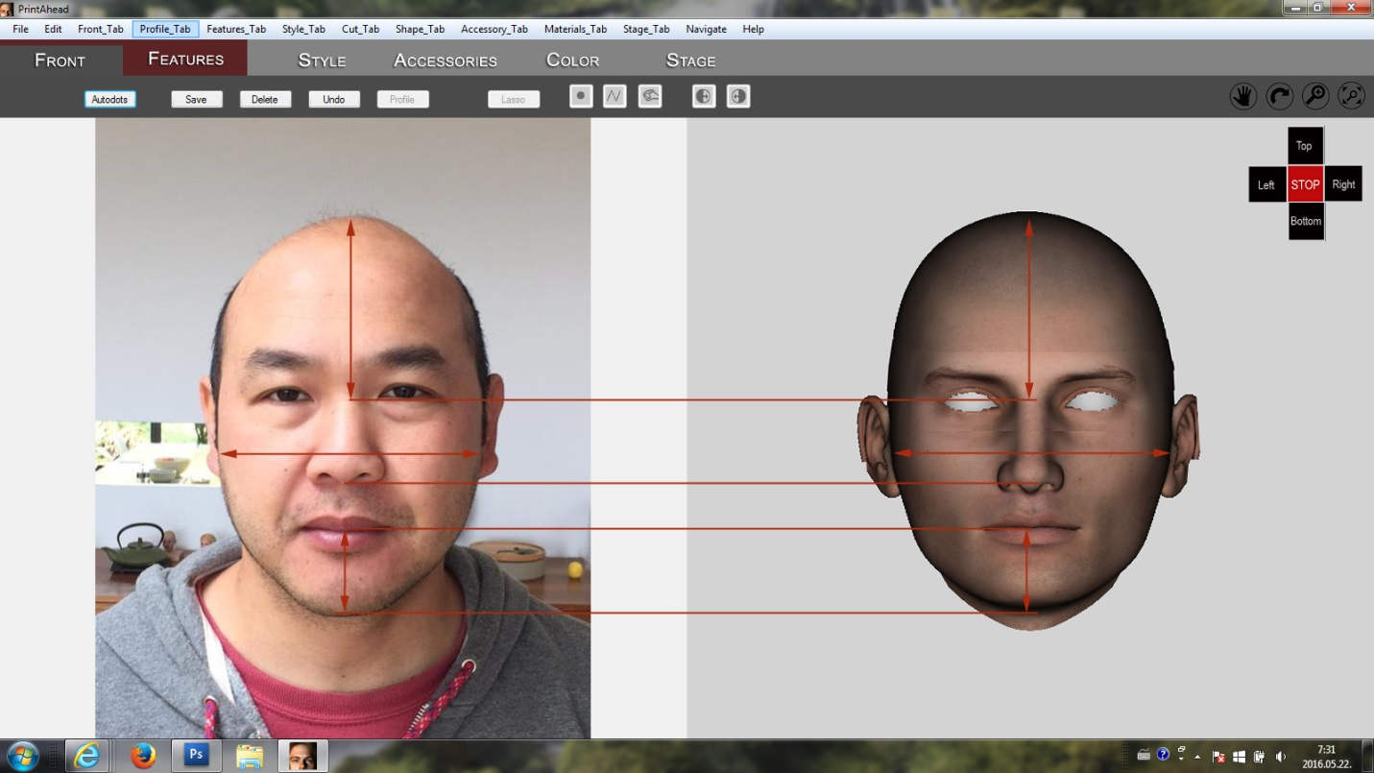

**New simplified combined texture/color movement ($150)**

In PrintAhead 2.0 there will be no need to separately setting texture and again shape. One set of dots will set them at the same time.

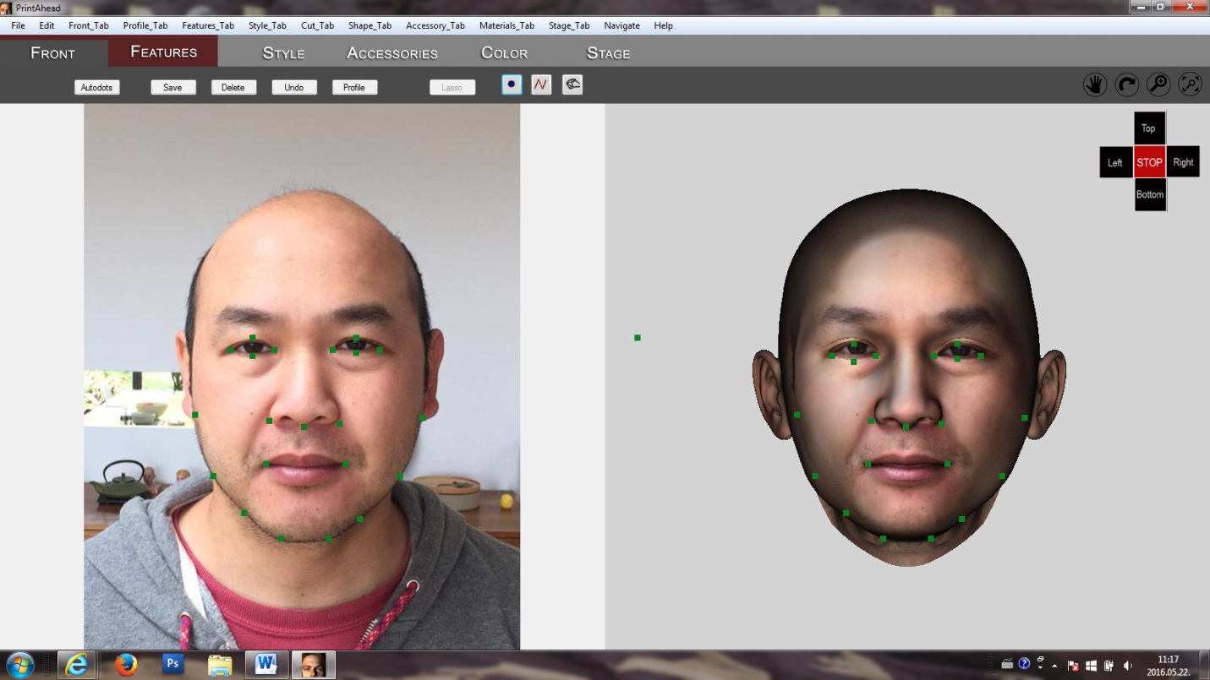

**Neck and Head will automatically pick up color ($150)**

Current condition

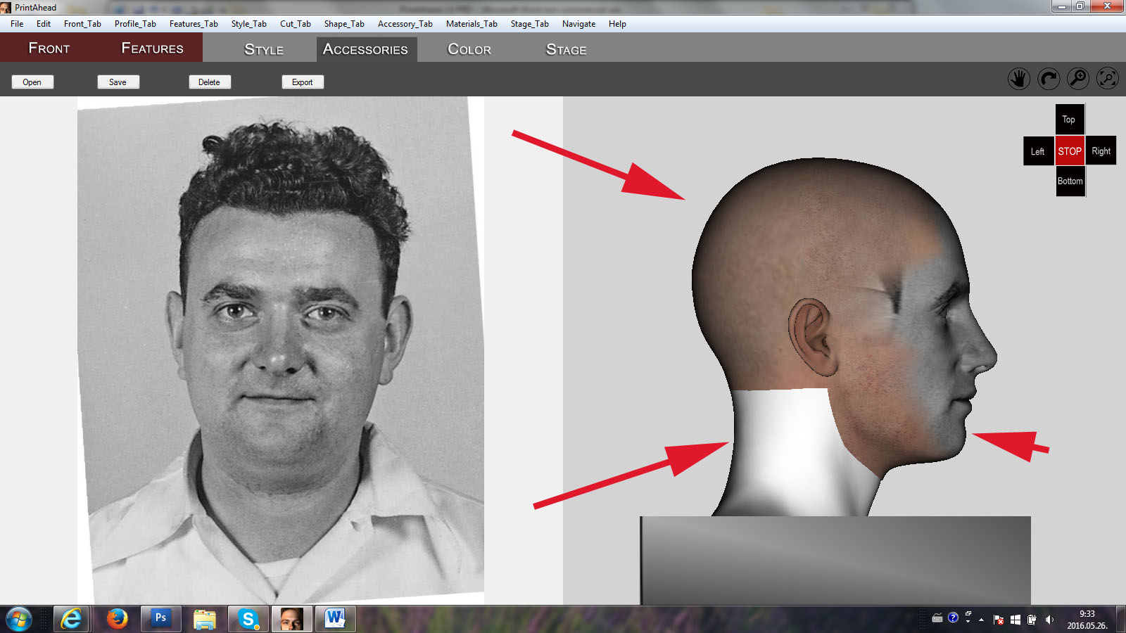

New condition

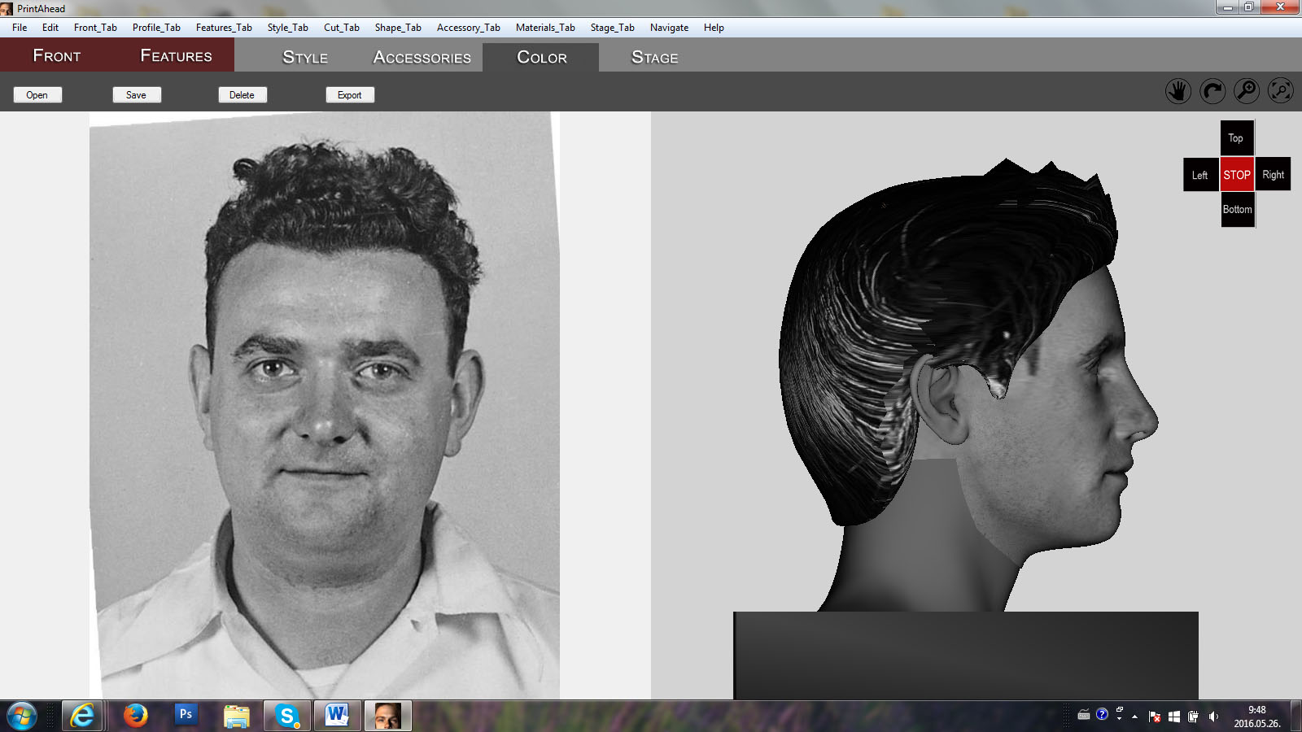

When Color Tab opens, neck will be automatically assigned color averaged from the adjoining areas.

Also, we could attempt to automatically eliminate edges (colors that contrast to the other areas).

If picture black&white, we adjust face and neck to b&w.

As part of this new way of handling texture maps, we should change the way texture maps are created.

Current condition:

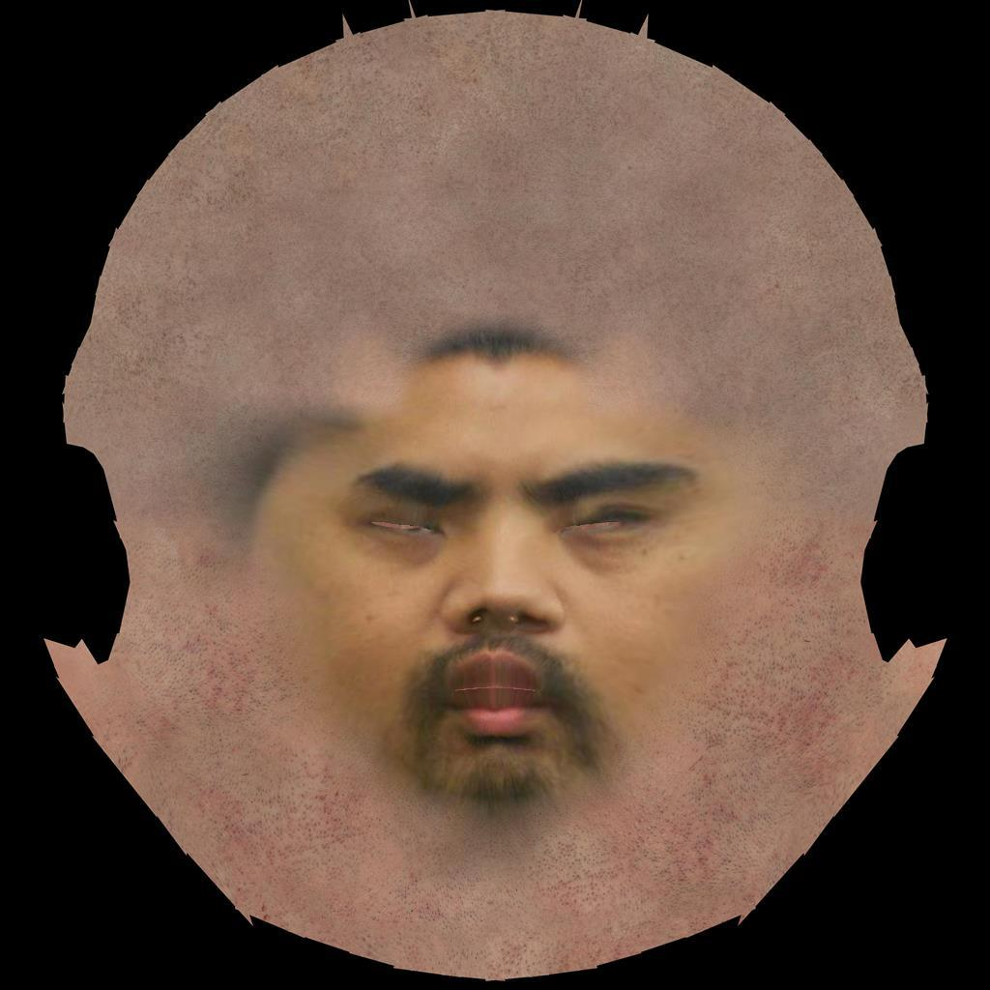

New condition:

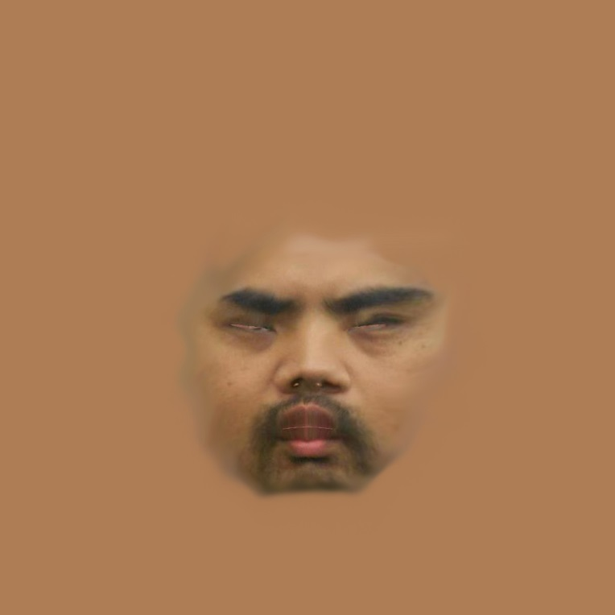

**Create new “wrinkle” tool ($250)**

This will add the capability to make better use of the Freehand tool.

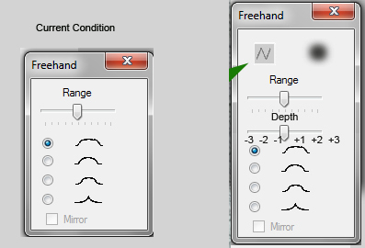

The desired condition on the right will have two ways to use Freehand tool:

1. As before (area selection grows/shrinks)
2. A line tool (which also can increase/decrease width).

In addition, there is a Depth slider, that makes a change either negative (wrinkle) or positive (bump).

With the new line option user draws a wrinkle line, sets its Range (width), selects a tool shape (maybe number 4) and a depth. Needs to also select mirror.

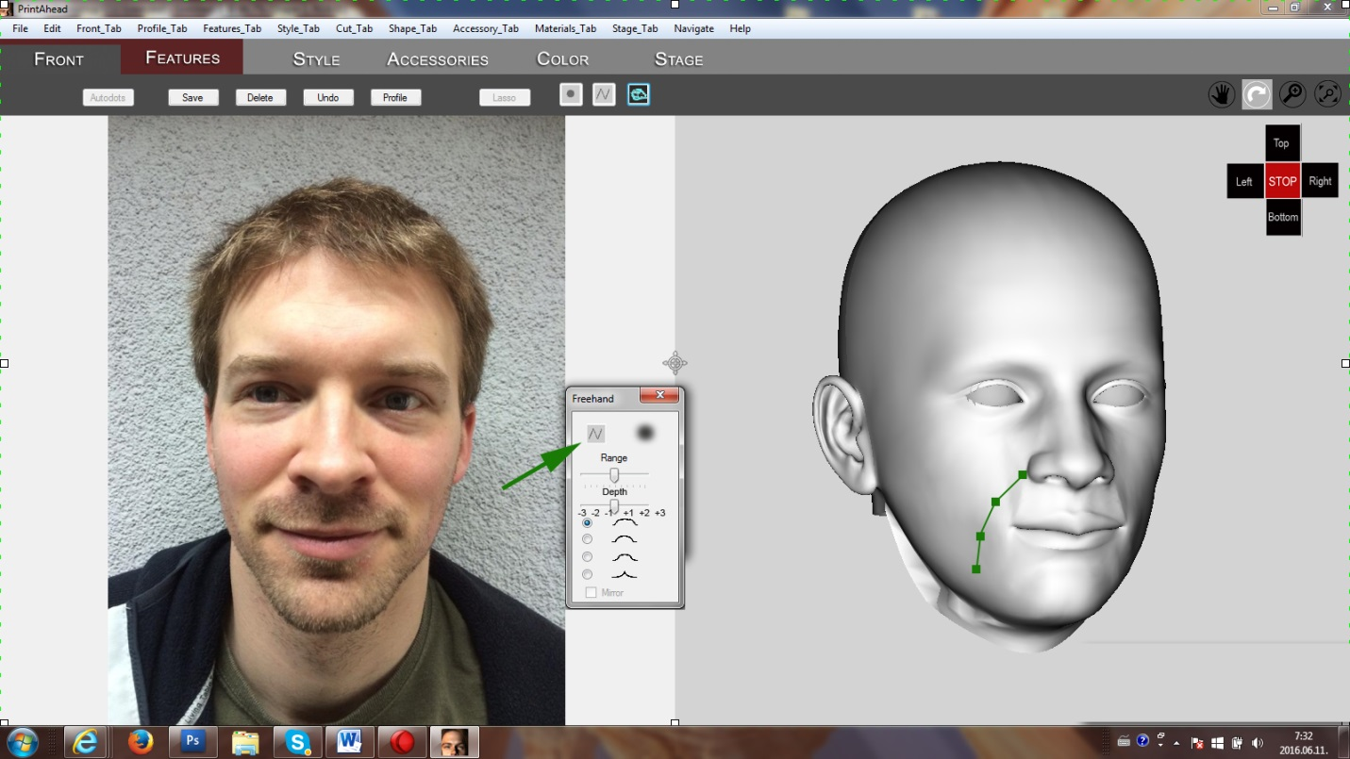

When user hits enter, the desired wrinkle appears.

(see also wrinkle video).

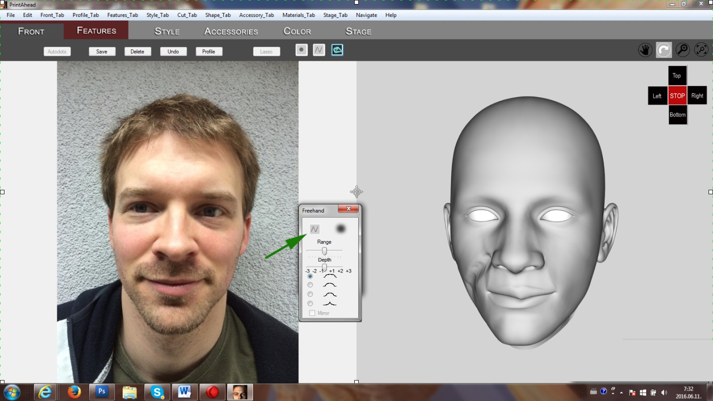

**Add copy of smooth slider to Profile screen ($100)**

1. When someone traces the profile, he/she should be able to make changes/move individual dots before hitting Enter.

Current condition:

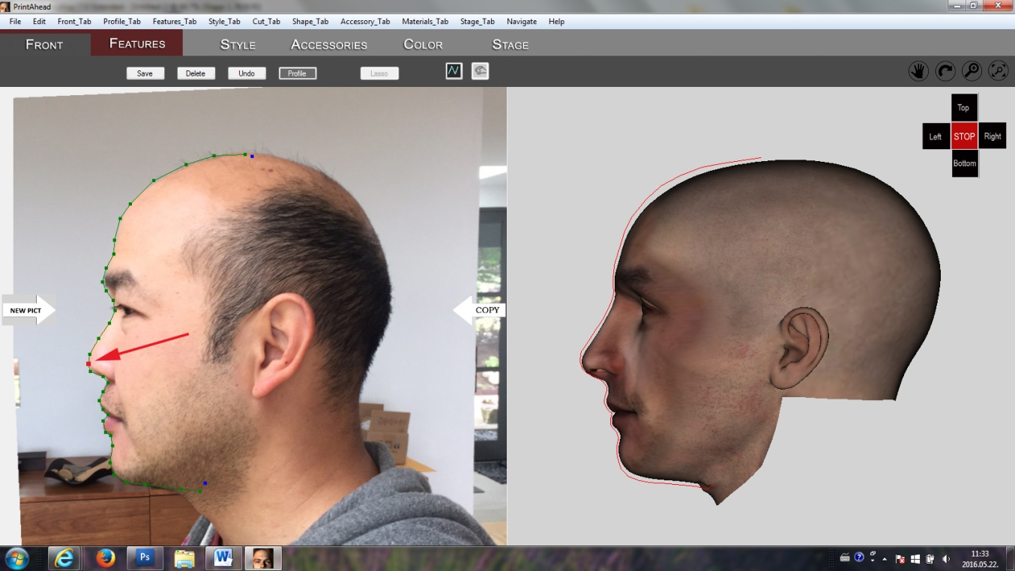

New condition:

1. After hitting “Enter”, a slider lets you adjust the percentage of how much of making the change will be used (same slider as the “Smoothen” slider in Stage tab).

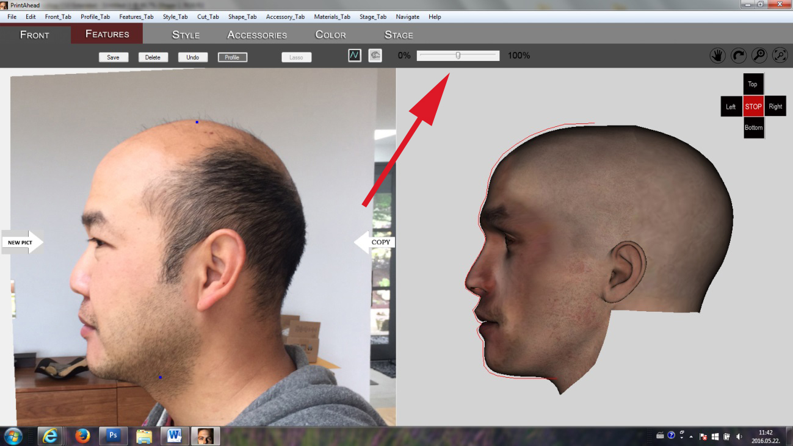

**Fixes**

1. Fix bug that wrinkles head if user makes additional changes after profile smoothing (here for example add weight). Please observe the wrinkles on the shape.

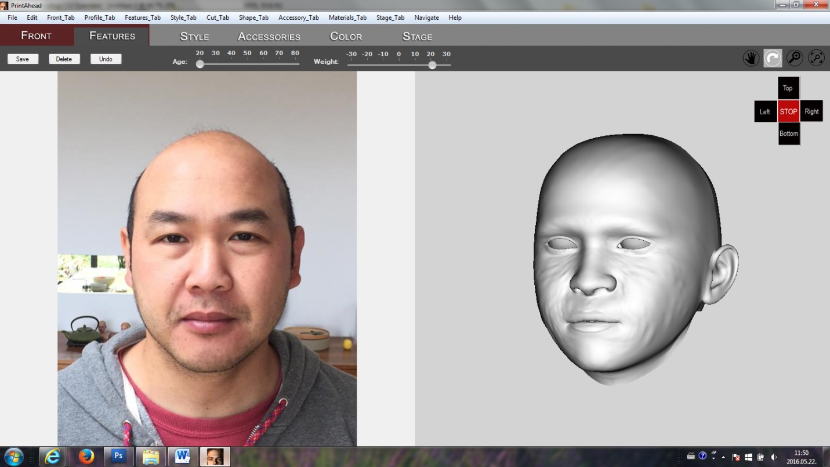

1. Implement 5 step REDO
2. Neck wrinkle. Pls smoothen

